Instructions for Using Intermediate Interactive Property Tax Template
By
Dave Neuendorf, Dodge County UW-Extension Office and
Kate Lawton, UW-Extension Local Government Center

This template allows you to use the G.R.E.A.T. Program database to illustrate how property taxes are determined and to show historic property tax trends for a hypothetical property in a selected Wisconsin Municipality.
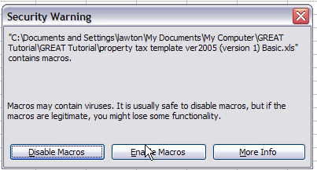
- When you open the spreadsheet, click on “Enable Macros” in the pop-up prompt window appears.
If you are having difficulty, make sure your Microsoft Excel© program is set to accept macros. Open Excel©. Go to “Tools”, “Options”, “Security”, “Macro Security”, and “Security Level”. Set at the “Medium” security level. When you open the spreadsheet, click on “Enable Macros” in the pop-up prompt window appears.
- Open “Intermediate Property Tax Template” in Microsoft Excel
- Open the GREAT software program (for a copy of the GREAT program contact your County Extension Office)
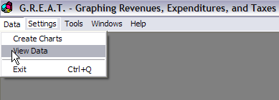
- Click on “DATA”

- Click on “View Data”

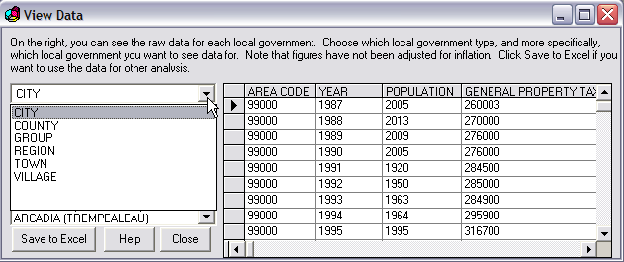

- Select “City”, “Town”, or “Village” from drop-down box

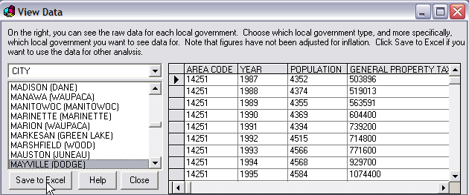
- Highlight the municipality you want to analyze
- Click on “Save to Excel”

- The data will be downloaded from the GREAT Program to a new Excel worksheet as shown below.
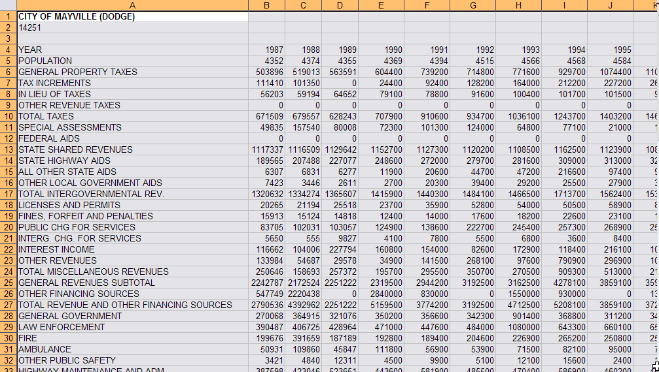

- Highlight the data you want to use in the new worksheet (be sure to include the year heading). It is best to copy all of the data from A1 to U87.
- Copy the highlighted cells
- Open the “Intermediate Property Tax Template” Worksheet
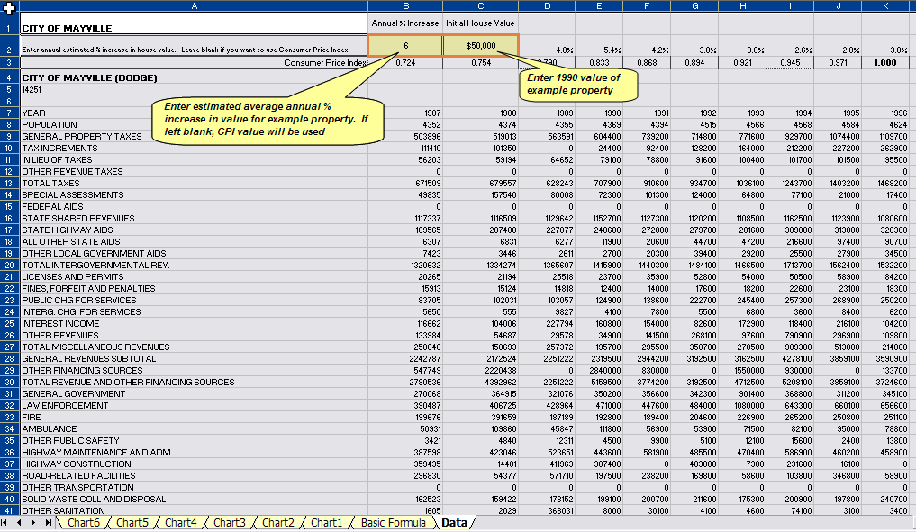
- Click on the “Data” tab at the bottom of the worksheet screen
- Highlight cell A4
- Paste the copied data to the template (CTRL – V)
- Once your data is pasted into the template, he first thing you should do is enter assumptions for
the 1990 value of the hypothetical property you want to analyze, and the average annual percent increase in value for the property. Enter this information in the cells at the top of the “data” worksheet. For example, if the 1990 value of the property is $30,000, enter that amount in cell C2. If you are assuming that the property’s assessed value increased an average of 4% each year, enter that amount in cell B2. If you leave cell B2 blank, the program will assume that the property value increased at the annual rate of inflation(CPI) for each year.

- Open the “Basic Formula” tab
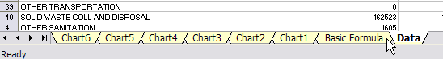
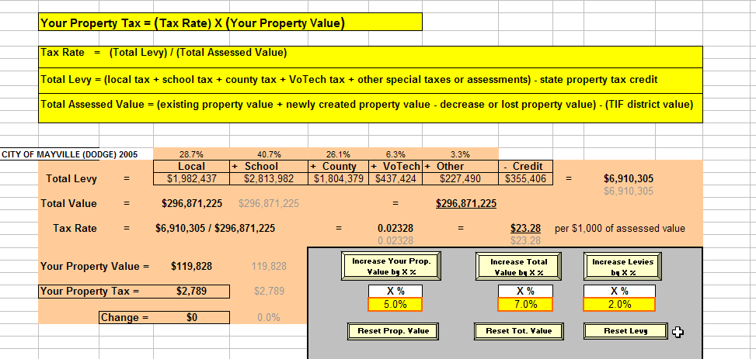

- The template now contains the data for your selected city, village or town. The grayed numbers are baseline reference figures. They do not change when you make calculations.
Note that the top yellow portion provides the basic formulas that are used in the calculations. The assessed value figure here is really the equalized value of property in a municipality, minus any TIF value. The GREAT software only includes equalized value data. Note also that the calculation for the total levy subtracts the state property tax credit from the total tax, when in fact it reduces the property tax for schools. Mathematically, the property tax amount is the same, but the property tax attributable to schools will be larger relative to the other districts than it is normally shown on the property tax bill.
- By changing the numbers in the yellow boxes in the bottom right, you can show how changes in the property value of a hypothetical property, changes in total valuation, or changes in the total levy will affect the property tax on the hypothetical property.
- To change a number, highlight a yellow box and type in a number (e.g., 2 for 2 percent change). Then click to the right of the box and then click on the button above the box.
- To reset each variable to its original value, click on the reset button below the yellow box.
- The base value for the hypothetical property is set in the cell at the top of the “Data” page as is the average annual increase in value.
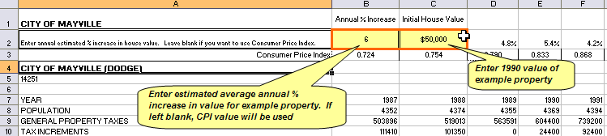
Note that you can change four variables with this template: percentage changes in the value of the hypothetical home, total value within the municipality, and the total levy. These changes are made with the yellow buttons on the basic formula page. The fourth amount that you can change is the base value of the hypothetical home on the data sheet. The changes entered on this worksheet (percent changes in hypothetical property value, total value in municipality, and the total levy) do not affect any of the charts.
Exploring Historic Property Tax Trends
There are six charts within template that show the relationships between the property tax increases over the years, where those increases occurred, increases in property value, and a comparison between the increased property tax and property values using a hypothetical home in a jurisdiction of your choosing. You select the charts by clicking on the tabs shown on the bottom of your screen.
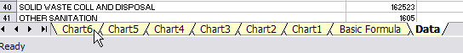
Charts 1 through 6 can be used to illustrate how the property tax bill for the target property has changed over time (1990 through 2005), how the property tax dollars have been distributed among the taxing jurisdictions, and which taxing jurisdictions have had the greatest effect on the target property’s tax bill.

Chart 1 – Property Tax vs. Value of Hypothetical Property
This graph, shown on the next page, plots the change in property taxes (red line) and in property value (blue line) for the hypothetical property. At first glance, property taxes look higher than property values based on the line positions. Actually, the scale for property taxes is on the left (0 to $3,000) and is significantly smaller than the property value scale on the right (0 to $140,000). The graph also shows the net change in the mill rate, the inflation rate, local full value, and the amount of increased property value that has been consumed by an increase in property taxes between 1990 and 2005. This last value says that the property owner paid $8,534 in taxes over the period above what would have been paid if the taxes had stayed at their 1990 level. His property value (wealth) increased by $69,828 over the same period. Therefore, additional taxes consumed 12.2% of the increase in wealth.

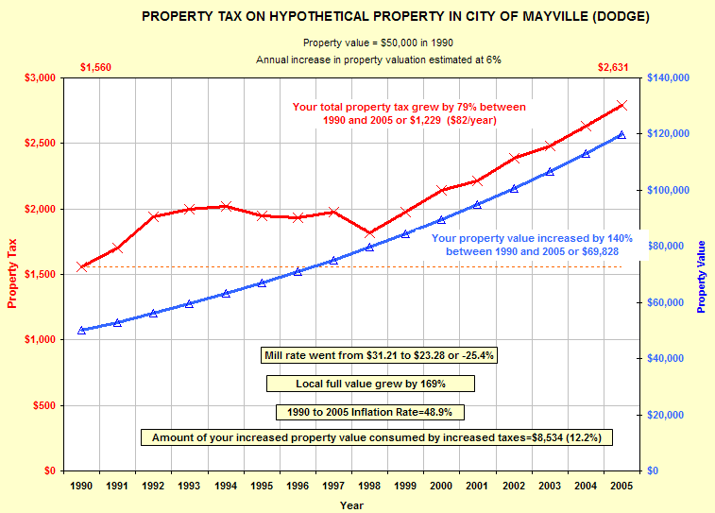
Chart 2 – Yearly Change in the Property Tax
This chart shows the change in dollar amount in the property tax from year to year and the trend line for the total tax bill for the hypothetical property. The chart illustrates more clearly the actual yearly dollar amount change in the property tax. Using the trend line by itself can overstate the actual growth in the tax bill. Note that the left hand vertical scale applies to the annual increase/decrease in the bar graph.
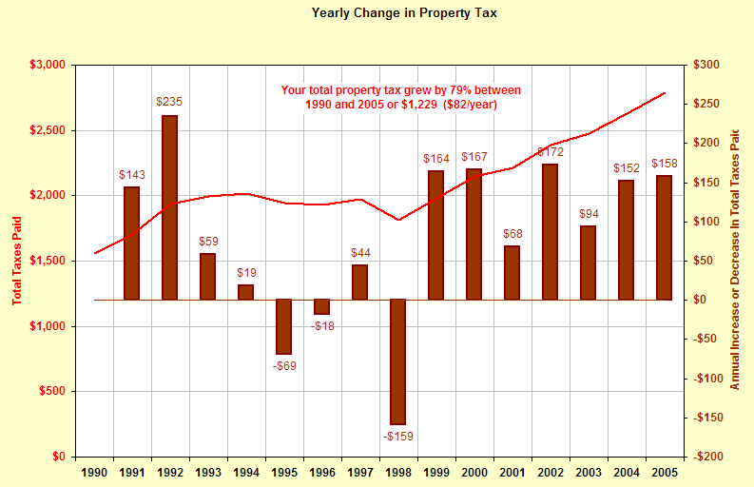

Chart 3 – Property Tax on Hypothetical Property
This chart begins to break down the property tax bill to show the dollar amount of property tax for each jurisdiction on the tax bill for a $50,000 home in Mayville between 1990 and 2005. The three numbers in red on the top of the graph indicate totals for those selected years.
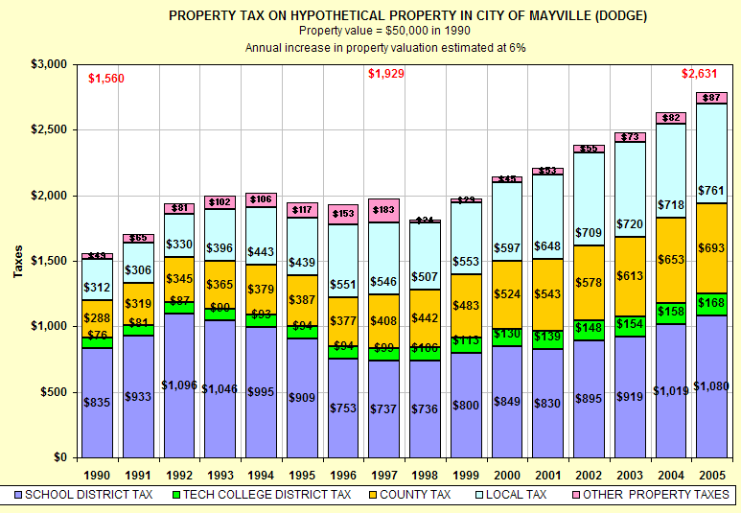

Chart 4 – Property Tax on a Hypothetical Property in Mayville
This chart, shown on the next page, is a slightly different illustration of the relative property tax bill composition, dollar amounts and trends. The shape and boundaries of each area indicates fluctuations of each jurisdiction’s tax on the property. The colored boxes indicate the absolute and percentage change for each taxing jurisdiction between 1990 and 2005.
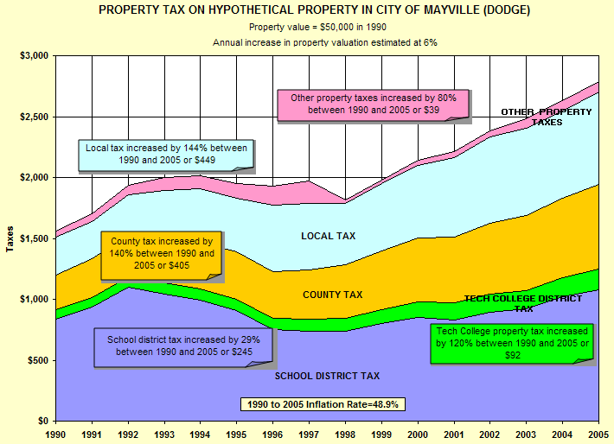

Chart 5 – Property Tax on Hypothetical Property
Chart 5 shows how each taxing jurisdiction’s share of the tax bill has changed between 1990 and 2005.
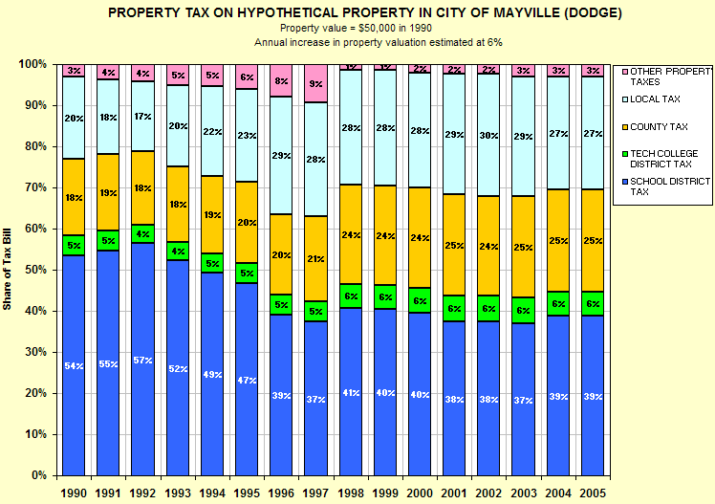

Chart 6 – Share of Property Tax Change
This chart shows the relative contribution each taxing jurisdiction made to the change in total tax on the property between 1990 and 2005. In this case, for a hypothetical home in Mayville valued at $50,000 in 1990 with annual increases in property valuation of 6%, the local tax made the largest contribution (32.9%) to the property tax increase between 1990 and 2005.
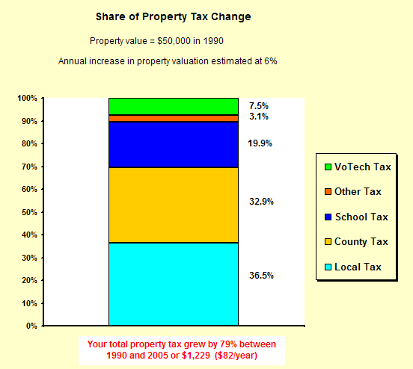
If the tax on the property for any of the taxing jurisdictions is lower in 2005 than it was in 1990, while the total property tax was greater in 2005 than in 1990, that jurisdiction’s share of the total increase will show as a negative contribution i.e. it made a negative contribution to the increase in total property taxes for the time period. Try entering a lower average annual percent increase in value for the hypothetical property to see this result.
If the total property tax on the hypothetical property is lower in 2005 than it was in 1990, a taxing jurisdiction’s share of the change will be shown as a positive value if its tax on the property was lower in 2005 than it was in 1990. It will be shown as a negative value if its tax on the property was greater in 2005 than it was in 1990. In other words, if the jurisdiction made a positive contribution to the total tax decrease, the value will be positive. If it made a negative contribution to the total tax decrease, the value will be negative.

Now you have the basics of walking through the intermediate interactive template. Have fun changing the variables, looking at different municipalities, and increasing your understanding of the interplay between property values and property taxes.

