

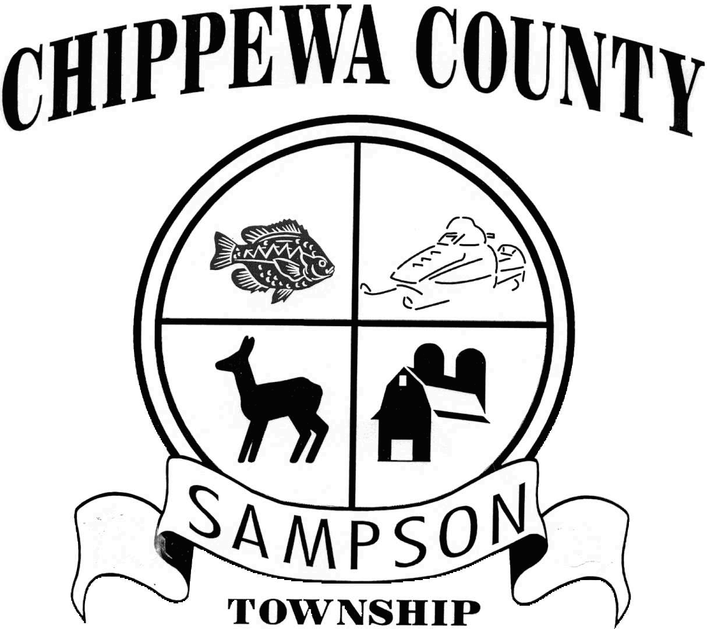The following profile is intended to provide a framework for discussing important issues relevant to your Town. For purposes of comparison, data from the Towns of Cleveland and Lake Holcombe will be used in this report. Both of these Towns are located in Chippewa County and were chosen for comparison because of similar population and community characteristics. However, every Town is unique. Service sharing agreements, geography, local preferences, and many other factors determine each municipality’s appropriate mix of taxes and services. Simply put, this report does not point toward a right or wrong level of taxation or service provision. Those are political decisions that are made by and for individual communities themselves.

Town of Sampson

***Trend Analysis***

***Report – April 2006***

Prepared by Andrew Dane

Community Development Agent

Chippewa County - UW extension

andrew.dane@ces.uwex.edu

715.726.7950

The report is divided into 5 sections:

* **Background:** A brief description of the community
* **Population and growth:** A brief overview of population trends and characteristics
* **Property values**: A look at how values have shifted and changed over time
* **Property taxes**: A look at who gets how much of your property taxes
* **Revenues**: How does your community raise money?
* **Expenditures**: How does your community spend money?

Hopefully, the information contained in this report will provide a background for a healthy discussion about the future of your community. Figures used in the report are from the Wisconsin Department of Revenue, the U.S. Census, and the Town of Sampson. Dollars amounts are adjusted for inflation and are expressed in 2005 dollars, unless otherwise noted.

# Background

The Town of Sampson is a rural Township in northern Chippewa County, whose Town Hall is located at 10770 270th Ave., New Auburn. The Town borders Barron County to the West and Rusk County to the North. Within the Town are two County Parks, the Ice Age National Reserve, and County Forest Land. The area is characterized by many lakes, trails, and other scenic amenities. There are four school districts that overlap the Town of Sampson: the Bloomer, Chetek, Lake Holcombe, and New Auburn districts. The Chippewa Valley Technical College overlaps the entire Town.

There are a total of 90.61 miles of roads within the Town, of which 19.06 miles are County roads and 71.55 miles are Town roads. In addition, 8.68 miles of State Highway 40 runs through the Town of Sampson, all of which is classified as Rural Minor Arterial. (Chippewa County Highway Dept. and Wisconsin Dept. of Transportation)

The 2005 Statement of Assessment provides a breakdown of the Town’s 41,285 acres by land use classification. Of the total acres in the Town, 32,334 are taxable. They include 9,759 acres of Productive Forest, 8,637 acres of Agriculture land, 7,719 acres of Undeveloped land, 2,840 acres of Private Forest Crop and Managed Forest Lands, 1,893 acres of Agricultural Forest, 1,235 acres of Residential land, 167 acres classified as ‘Other,’ 79 acres of Commercial land, and five (5) acres of Manufacturing land (Figure 1). The remaining 8,951 acres within the Town are tax exempt. Those acres include DNR lands (2,696), County Forest Cropland (4,829), County acres (372), and lands owned by non-profit organizations (1,054). Note: Each year, the DNR makes a payment to all municipalities where there is land in DNR ownership (Payment in lieu of taxes).



**Taxable land in Bold Font**

Figure 1: Town of Sampson

Land Use Classification (acres) (2005 Statement of Assessment)

# Population and Growth

Figure 2 shows actual population change for the Town of Sampson between 1991 and 2005, compared with the Town of Cleveland and the Town of Lake Holcombe. Over the period 1991 to 2005, the Town of Sampson grew 5.7%, from a population of 820 to 867. Lake Holcombe grew by 15.3%, from a population of 928 to 1070. The Town of Cleveland grew 27.8%, from a population of 760 to 971.

600

700

800

900

1,000

1,100

1,200

1991

1992

1993

1994

1995

1996

1997

1998

1999

2000

2001

2002

2003

2004

2005

CLEVELAND

SAMPSON

SAMPSON

LAKE HOLCOMBE

Figure 2: Population change: 1990-2005 (WI Dept. of Administration)

*(Note: 2000-2001 jumps in population are partially due to adjustments made*

*as a result of the 2000 U.S. Census)*

While Sampson may not be growing as fast as Lake Holcombe or Cleveland, its residents are the most mobile in Chippewa County. The percent of the Town’s year 2000 population that lived somewhere else in 1995 was higher in the Town of Sampson than in all other Chippewa County Towns. Over the period 1995 to 2000, 41% of Town residents had changed homes, 23% had changed Counties, and 8.5% had changed States.

***Do these figures include seasonal residents*?** **NO.**  According to the 2000 U.S. Census, there are 101 seasonal residences in the Town of Sampson. Assuming an average household size of two (2), that would make for an additional 202 seasonal residents that reside only part time in the Town of Sampson

## Income

The Town of Sampson had an average Household Income of $36,971 in 2000, compared with an average Household Income of $50,935 for all Towns in Chippewa County. Both Cleveland ($39,191) and Lake Holcombe ($39,702) had slightly higher Household Incomes than Sampson. Lower household incomes ***may*** be attributed to smaller average household sizes, higher numbers of retirees, lower wages, higher unemployment, or other factors.

**$50,935**

**$39,702**

**$39,191**

**$36,971**

$0

$10,000

$20,000

$30,000

$40,000

$50,000

$60,000

Average

(all Chippewa Towns)

Lake Holcombe

Cleveland

**Sampson**

**Mean Household Income**

Figure 3: Household Income (2000 U.S. Census)

Figure 4 on the following page provides a breakdown of average Town incomes. Sampson and Lake Holcombe have very similar income characteristics. Both Towns derive relatively little income from Salaries and Wages (62% and 60%, respectively). On the other hand, both Towns rely quite heavily on Retirement Income and Social Security. In 1999, 18% of Sampson’s Town resident income came from retirement and Social Security, the second highest such figure for any Town in Chippewa County, trailing only Lake Holcombe (19%). The County average for this figure was 10% in 2000. Ten percent of Town resident income was derived from self employment in 1999, the same percent as the average for all Chippewa Towns.

**76%**

**10%**

**4%**

**72%**

**10%**

**10%**

**62%**

**18%**

**10%**

**60%**

**19%**

**11%**

0%

20%

40%

60%

80%

100%

Lake Holcombe

**Percent contribution to total 1999 Town Resident Income**

Salaries and Wages

Retirement Income

& Social Security

Self-Employment

**Sampson**

Average

(all Chippewa Towns)

Cleveland

# Figure 4: Income Characteristics (2000 U.S. Census)

# *Figures rounded to nearest percent*

# Property Values

In 2005, the Town of Sampson had the third highest equalized value of all Chippewa County Towns ($176 million), trailing only Eagle Point ($261 million) and Lafayette ($414 million), two Towns with significantly higher populations than the Town of Sampson. Also known as full value, equalized value is defined as 100% of market value. Equalized values are used to distribute state aids and jurisdictional taxes that overlap multiple tax districts, such as the County, State, or Technical College.

**2005 Total Equalized Values (rounded to nearest million)**

**414**

**261**

**176**

0

50

100

150

200

250

300

350

400

450

Lafayette

Eagle Point

**Sampson**

Figure 5: Equalized Values for Wisconsin Municipalities (WI Dept. of Revenue)

Over the last several years, property values have increased dramatically in the Town of Sampson, both as a result of new construction and increased market values of existing property. Figure 6 below highlights how total equalized value rose from approximately 58 million in 1995 (2005 dollars) to 177 million in 2005. All of the increase was due to increases in Real Estate values. Personal property (boats, equipment, etc…) contributed approximately one half million in both 1995 and 2005.

**57**

**0.56**

**175.7**

**0.56**

0

20

40

60

80

100

120

140

160

180

**Millions**

1995

2005

Real Estate

Personal

Property

**Sampson Equalized Values: 1995 and 2005 (millions, 2005 dollars)**

Figure 6: Equalized Values for Wisconsin Municipalities (WI Dept. of Revenue)

The pie charts on the following page (figures 7 and 8) show the composition of equalized value for Sampson in 2005 and 1995. From 1995 to 2005, the percent of equalized value attributed to residential shrank slightly from 82% to 80%. On the other hand, the percent of equalized value attributed to forest land grew from 8% to 13%. Agricultural land dropped from 6% to 1% of total equalized value from 1995 to 2005. This trend may be partially explained by the way agricultural land is valued. For the 2000 assessment year and beyond, agriculture property has been assessed based on its “use,” or ability to generate income, rather than market value. The category ‘Other’ represented 0% of the total equalized value in 1995 and 3% in 2005. This category or *class* was not used until 1996. It includes agricultural buildings, improvements, and the land necessary for their location so that agricultural land could be assessed at its use value.

Figure 7: 2005 Town of Sampson Equalized Value (WI Dept. of Revenue)

**EQUALIZED VALUE BY CLASS - 2005 SAMPSON**

RESIDENTIAL

80%

COMMERCIAL

1%

MANUFACTURING

0%

AGRICULTURE

1%

UNDEVELOPED

1%

AGRICULTURAL FOREST

1%

FOREST

13%

OTHER

3%

**EQUALIZED VALUE BY CLASS - 1995 SAMPSON**

RESIDENTIAL

82%

COMMERCIAL

3%

MANUFACTURING

0%

AGRICULTURE

6%

UNDEVELOPED

1%

AGRICULTURAL FOREST

0%

FOREST

8%

OTHER

0%

Figure 8: 1995 Town of Sampson Equalized Value (WI Dept. of Revenue)

# Property Tax

Below are two pie charts that show where property taxes paid by Town of Sampson landowners went in 1995 and in 2005 as a percentage of the total property taxes levied within the Town. The ‘Local Tax’ portion is that which went to the Town of Sampson itself.

**TAXES – 1995**

**SAMPSON**

Other

0.8%

Local Tax

17.4%

County Tax

16.6%

Technical College School District

Tax

7.3%

Gross Elementary/Secondary

School District Tax

57.9%

Figure 9: 1995 Town of Sampson Property Tax distribution (WI Dept. of Revenue)

**TAXES - 2005**

**SAMPSON**

Gross Elementary/Secondary

School District Tax

59%

Technical College School

District Tax

10%

County Tax

22%

Local Tax

8%

Other

1%

Figure 10: 2005 Town of Sampson Property Tax distribution (WI Dept. of Revenue)

The amount of property taxes going to school districts increased from 57.9% of the total property tax bill in 1995 to 59% in 2005. Local taxes dropped from 17.4% of the property tax bill in 1995 to 8% in 2005. In contrast, County taxes increased from 16.6% to 22% of the property tax bill over this period, along with Technical College taxes, which increased from 7.3% to 10% of the total property taxes collected in the Town.

In 2005, Sampson property taxes contributed $1,756,213 to the four school districts, followed by $640,636 to Chippewa County, $283,969 to Chippewa Valley technical college, $240,855 to the Town, and $33,069 to the State of Wisconsin.

# Revenues

The Town of Sampson had revenues of approximately $428,910 in 2005. The primary revenue sources for 2005 are shown below in the pie chart. As a percent of the total revenue pie, General Property Taxes represented 53% of Sampson’s revenues in 2005, or $236,360 dollars.State Transportation aids totaled $130,579 or 29% of Town revenues, followed by Other Aids ($34,025 or 8% of total revenue), State Shared Revenues ($28,040 or 6%), Miscellaneous revenues ($9,892 or 2%), and Charges/Fee revenue ($4,096 or 1%).



Figure 11: Town of Sampson Revenues (2005 Town of Sampson Budget, 2005 Town of Sampson Annual Report)

# Expenditures

Below is a pie chart showing how the Town of Sampson spent its revenue in 2005. The largest category of spending was Roads and Transportation (69.7%), followed by Protective Services – fire, ambulance, (16.5%), Administration (12.7%), Health and Human Services (0.7%), Sanitation (0.3%), and Other (0.1%).

**EXPENDITURE SHARES - 2005 SAMPSON**

HIGHWAY

MAINTENANCE/SHOP

25%

HIGHWAY

CONSTRUCTION/EQUIPMENT

36%

FIRE

17%

AMBULANCE

1%

GENERAL GOVERNMENT

18%

RECYCLING

1%

HEALTH/HUMAN SERVICES

1%

OTHER

1%

Figure 12: 2005 Town of Sampson Annual Report

Below is the per capita figure for ambulance spending. Ambulance costs are consolidated with Bloomer ambulance. Better collections and lower losses are thought to have contributed to the downward trend in per capita expenditures.

**PER CAPITA AMBULANCE EXPENDITURES**

**SAMPSON**

$0

$2

$4

$6

$8

$10

$12

1990

1991

1992

1993

1994

1995

1996

1997

1998

1999

2000

2001

2002

2003

2004

2005

**Dollars Per Person (2005 $)**

Sampson

Towns between 501 and 1,000 people

2004, 2005 PER CAP AVG. NOT AVAILABLE

Figure 13: 2005 Town of Sampson Annual Report and WI Dept. of Revenue

**PER CAPITA FIRE EXPENDITURES**

**SAMPSON**

$10

$20

$30

$40

$50

$60

$70

$80

$90

1990

1991

1992

1993

1994

1995

1996

1997

1998

1999

2000

2001

2002

2003

**Dollars Per Person (2005 $)**

Sampson

Towns between 501 and 1,000 people

Figure 14: Per capita fire expenditures, WI Dept. of Revenue

The figure above shows per capita fire protection costs from 1990 to 2003. Costs show a steady increase, which may be attributed to increases in equalized value. Fire protection is done through an agreement with New Auburn, and total costs were $74,256 in 2005. The figure below shows per capita spending on roads and transportation, from 1990 through 2003. The trend line includes both capital and operating budgets, which likely helps account for the spikes in spending. The comparison trend line is smoother because it is an average.



Figure 15: Per capita transportation expenditures, WI Dept. of Revenue

Figure 16: 2003 Town of Sampson debt index, WI Dept. of Revenue

The figure above shows the percentage change for debt spending as a result of the bonding that occurred in 1993 to build the new Town Hall. Currently, the Town of Sampson has no general obligation debt. The use of general obligation debt to finance infrastructure improvements is very common, especially in areas that are experiencing rapid growth.

**Summary**

The Town of Sampson is a rural Township with many different land uses. Unlike the nearby Towns of Lake Holcombe and Cleveland, the Town of Sampson has experienced relatively little year round population growth over the past 15 years. Its residents are highly mobile, however. Over a five year period from 1995 to 2000, 41% of Town residents changed homes.

In terms of income, residents of the Town of Sampson rely heavily on retirement income and social security. Only 62% of the income generated in the Town of Sampson in 1999 came from Salaries and Wages (latest available data from 2000 census).

Over the past several years, the Town of Sampson has experienced a sharp rise in equalized values, both as a result of new construction and increases in the market value of existing homes and property. In fact, the Town has the third highest total equalized value of all Towns in Chippewa County. In 2005, 80% of the total equalized value was attributed to residential land and buildings.

Residents in the Town of Sampson pay property taxes to fund a number of different local units of government. In 2005 the largest recipients of Town-generated property taxes were the school districts. Only 8% of locally generated property taxes went to fund Town government.

Approximately 44% of Town of Sampson revenues came from outside sources in 2005. Most of these revenues come in the form of transportation and shared revenue aids from the State.

Like most Towns, the Town of Sampson spends the majority of its revenue on roads and road maintenance, which together made up 61% of all expenditures in 2005. Public safety was the second highest expense in 2005, comprising just over 18% of the total. There is some concern about the ability to maintain the current level of road upkeep, which has recently averaged around 4.5 to 5.5 miles per year. Declining State Shared Revenues and relatively flat Transportation Aids (which aren’t keeping up with inflation) make this a concern.

This brief report highlights some of the big picture demographic and public finance characteristics for the Town of Sampson. in Chippewa County. These characteristics are not the only ones to be analyzed and reviewed, but represent a broad overview of a few key trends.